**DOM** - Document Object Model

**CSSOM** – Cascading Style Sheet Object Model

**Dom Tree :**

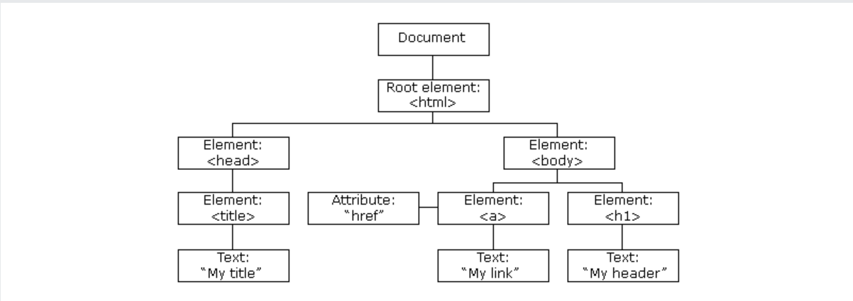

**CSSOM Tree :**

